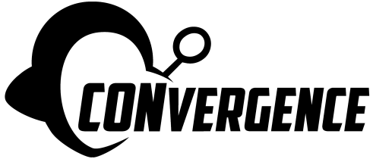 2025 Art Show Artist Resource

Whether this is your first art show or thousandth, we want your experience with CONvergence Art Show to be smooth and successful!

Here you will find terms, procedures, and simple explanations for some of our most commonly asked questions and resources to help everyone succeed in putting on a great show.

Table of Contents:
Term Glossary
Step by Step (how to be a CONvergence Art Show artist)
Further Resources

Art Show Term Glossary
CONvergence welcomes all artists in all tangible media to display art in our show. Both amateurs and professionals are welcome. If this is your first show- welcome! If this is your thousandth show- welcome! As a convention art show is different from a regular gallery or selling in a booth, we want to make sure everyone is on the same page with terminology and are thus providing a glossary.

2D - An abbreviation for “Two Dimensional.” Commonly used in the art world for any pieces of art that are flat. Usually paintings, prints, stickers, etc.

3D - An abbreviation for “Three Dimensional.” Commonly used for anything that is not a flat piece of artwork.

Agent - (see “Representative”)

Amateur - CONvergence has awards for both amateur and professional artists. We make no distinction between the two categories, it is self-identified.

Art Market - Previously known as “Print Shop” the CONvergence Art Show Art Market was rebranded in 2020 to help artists understand all art is welcome in this section of the show, not just prints or 2D artworks.

Artist(s) - Anyone creating and submitting pieces to be displayed at CONvergence Art Show.

Auction - (see “Live Auction” and “Silent Auction”)

Bid - A number representing monetary value placed upon a “Bid Tag” on a gallery piece to attempt to purchase an artwork from an artist at the stated price. Pieces in the Art Market do not have bids, only a set price to purchase at.

Bid, Minimum - The lowest monetary amount a buyer/bidder may place on an artwork available for sale in the Art Show Gallery. The lowest allowed minimum bid is $5.

Bid Tag/Bid Sheet - A quarter sheet of paper attached to any artwork in the Art Show Gallery that allows bidders to write their information and what price they would like to bid on the artwork. Bids should be in whole dollar increments.

Binder Clip - A particular type of office supply with a black, triangular base, and silver, antenna-shaped handles. They come in multiple sizes and are used for hanging art without hangers on gridwall.

Business cards - A small card with information about yourself that can be placed in the Art Gallery or Art Market next to your artwork so buyers know how to contact/follow you outside the Art Show.

Commission - A percentage taken of any sales by the Art Show to cover costs of hosting the Art Show.

Display Fee - An upfront cost of putting pieces of art into the CONvergence Art Show Gallery.

Edition - Terminology to indicate if a piece belongs to a limited run or is an original piece of artwork. Unlimited editions are not numbered and may also be called “open” runs.

Gallery - The main section of CONvergence’s Art Show, created by a conglomeration of gridwall panels and tables, where art is displayed that has been submitted by artists. In this area of the Art Show, items are purchased via silent auction.

Gridwall - Heavy duty metal panels that can be configured to create walls, tables, and more for art to be displayed on. They are not solid metal, but instead have a series of vertical and horizontal bars in a grid, hence the name.

Guidelines - A term referring to CONvergence Art Show documents that explain what you are agreeing to by becoming a CONvergence Art Show artist.

Limited Edition - An art term for a series of prints that will only be printed a limited number of times. Each print is numbered, according to the series and placement in the printing. (eg: 24/100)

Live Auction - An event put on by Art Show on Saturday night. All pieces that receive over a certain number of bids (see the Guidelines document) go to the Live Auction where they are available for additional live bidding.

Mail-in – Artists who choose to ship their artwork to the designated address ahead of time instead of having their art brought to the hotel.

Media/Medium- The materials used to create a piece of artwork. This can be almost anything, from oil and canvas to soldering on metal. It must be sturdy enough to be displayed and not excessively fragile.

NFS - Acronym, “Not For Sale.” Used to designate a piece you would like displayed for public viewing, but is not available for purchase.

OOAK - Acronym, “One Of A Kind.”

“One Space” - A term used in our Gallery. One space is equal to one full gridwall (2’x6’) or one half table (1.5’x3’)

Original - An art term that means a piece is not a reproduction via printing or other duplication methods.

Print - An art term that means a piece of artwork has been duplicated from the original.

Print Shop - (see “Art Market”)

Professional - CONvergence Art Show has separate awards for professional and amateur artists, but makes no distinction itself. Artists may choose to self-identify depending on their own judgement.

QR Code – An image that allows a phone camera to scan it and open a webpage. These are banned, as phone camera use is not allowed in the CONvergence Art Show. We expressly ban taking of pictures, unless it is an artist taking pictures of their own work with a staff member present.

Quick Sale - A bid type that means the artwork is purchased immediately by the buyer/bidder. No more bids may be placed on the item and it does not go to auction. Items with bids already may not be quick sold.

Ready to Display - A term for artwork that means it is finished. No more changes will be made to it. In the case of paints (oil especially) it is dry. Hangars have been attached, or it may have binder clips put on to hang from S hooks. 3D works are stable or have specially made bases.

Representative - (Sometimes known as “Agent”); A Person other than an artist who has permission to bring and display art in CONvergence Art Show. This person is not claiming to have created the artwork, they are representing the artist.

S hook - A piece of hardware, usually metal, shaped like an “S” used to attach items and artwork to gridwall for display in Art Show.

Silent Auction - Term for any art show where bidders peruse items at their leisure and put bids on a sheet. This is in contrast to a live auction, where items are presented and bidders are actively placing bids concurrently.

Sunday Sale - Specific Art Show term wherein any artwork that has not been sold via bidding can be purchased at the stated price on Sunday. If an artwork does not have a Sunday sale price, it CAN NOT be sold on Sunday through the CONvergence Art Show.
Walk-in – Any artist who has not fully filled out their paperwork before arrival for inclusion in the CONvergence Art Show and does not have space reserved for them ahead of time.

Step by Step
So you’d like to be a CONvergence artist? Here’s the step by step!
- Read the Guidelines.
The Art Show Guidelines and the Artist Resource exist to help answer questions you might have about being a CONvergence artist. The Guidelines also outline rules you agree to abide with while displaying any art in our Art Show.

- Make art!
You can put up to 20 pieces in the Gallery. Space in the Art Market is first come, first placed. Art needs to be finished and able to be displayed with available equipment (tables, gridwall, S hooks, binder clips). You should make special arrangements if you need to bring in your own equipment (eg: a mannequin) or your art is especially large. You may not submit AI generated art to the CONvergence Art Show.
- Fill out the Artist Information Form.
We do NOT save space if you have only filled out the Artist Information Form, you must also fill out your Gallery and/or Art Market Inventory as well.

- Fill out the Gallery Display Inventory Sheet. (optional if not displaying in Gallery)
Refer to the Term Glossary if you need help understanding the different bid categories. Be sure to give us a concrete idea how much space you might need in the gallery. Unless you contact us directly about doing so, we will not save larger than one space. If you do not put in a Quick Sale or Sunday Sale price, those options will be unavailable to buyers.

- Fill out the Art Market Inventory Sheet. (optional if not displaying in Art Market)
If you plan to put any items in the Art Market, we need an inventory of those items, too. Remember, we do not reserve space in the Art Market, it is only first come, first placed starting Wednesday at Noon. Yes, you may choose to only put art in the Art Market.

- Here is where your path might diverge, depending if you are bringing the art in person or mailing it.

6A. Bringing art in person.
Get yourself (or your representative) and your art to CONvergence’s location on Wednesday from Noon to 5pm or Thursday 10am to 7pm (Art Show opens to CONvergence attendees at 2pm). We will have Art Show helpers in the drop off zone to quickly remove art from your vehicle on Wednesday. If no helpers are currently available on Wednesday, or you are bringing art on Thursday after 2pm, please park your vehicle instead and proceed to the Art Show.

7A. Pay any hanging fees and pick up your bid tags. Check with the staff member(s) in charge of placement to locate the space for your artwork.

8A. Double check information on your bid tags is correct and begin the process of placing your artworks. If this is a new experience and you would like help, please feel free to ask! We have links to various gridwall accessories the Art Show has available in the Resources section.

9A. Pick up your art on Sunday between 3-6pm. It will probably be in a different location because things shift around from Wednesday through Sunday and it may have also sold! Check in with the desk to get an inventory sheet and check if everything is correct. If art is sold, we will send a check within 6 weeks of the Art Show conclusion.

10A. If you have further questions, please reach out to us!

6B. Mailing in art.
Package your art carefully in a sturdy container and make sure it arrives by the submission deadline. See the guidelines and the mail-in sections specifically for extra details about fees to be paid and some notes about shipping.

7B. Mail in art will be unpacked by an Art Show volunteer. It is checked against your inventory sheets and a proper location is secured within the Gallery. Art pieces are displayed according to any directions (if given) as closely as possible. You do not need to supply directions.

8B. Once the show is complete, we will double check inventory and repack any artwork that has not been sold. It will be mailed back according to your preferences, and we will send a check within 6 weeks of the Art Show conclusion.

9B. If you have further questions, please reach out to us!

Further Resources
CONvergence Art Show is continuing to expand its work into the Twin Cities art community at large by providing resources to CONvergence artists. This area of our Artist Resource is currently in the founding process. Let us know if there are things you believe could be useful in this area of our documentation.

Pictures of various hooks and gridwall accessories Art Show currently possesses:
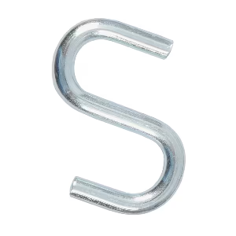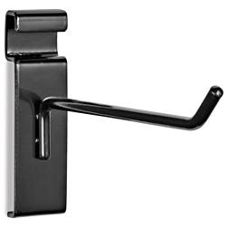
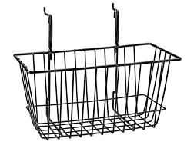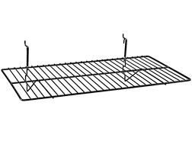
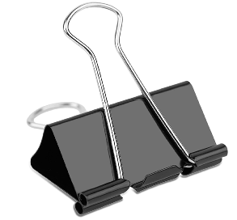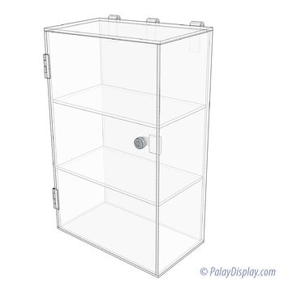
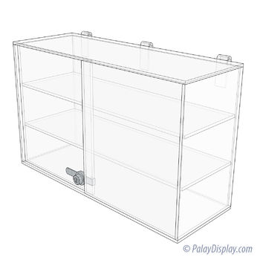
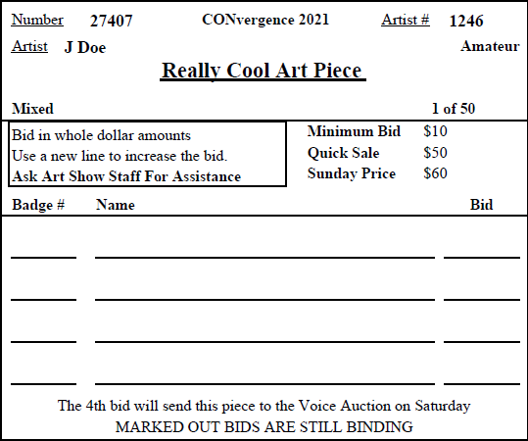

The artist and/or their agent ("Artist") hereby indemnifies and saves harmless Convergence Events, Inc., from each and every and all losses, claims, demands, obligations, liabilities, indebtedness and causes of action of every kind, type, nature or description whatsoever, whether known or unknown, as if expressly set forth and described herein, which Artist may incur, suffer, become liable for, or which may be asserted or claimed against Convergence Events, Inc., as a result of the acts, errors or omissions of Artist.

