All mail & deliveries should be sent to: | 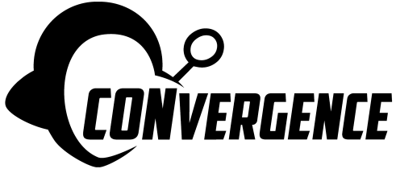  Art Show Artist Information | Mail not received by:  June 29, 2025  Will be returned unopened

CONvergence Art Show

^{c}/_{o} Charlie Horne

160 Lost Lake Court
Mahtomedi, MN 55115-1865
,
Please read the Art Show Guidelines before signing this form; your signature indicates that you will abide by these guidelines. Contact Art Show Staff (artshow@convergence-con.org) as soon as possible if you have any special display needs or questions. Additional forms are available at http://www.convergence-con.org/get-involved/artists/.

Artist Name/Business Name (for Display/Bid Sheets) |  |  | Phone, including Area Code
Name for Check (if different – sometimes representative’s name is used if applicable)

Primary Address

City | State | Zip
Email |  | Website

I consider myself:  Professional  Amateur

Representative appointed to act on my behalf in a binding manner (if applicable)

Secondary address

City | State | Zip
Phone |  | Email

This is how Art Show patrons can contact me:
____________________________________________

I give permission for CONvergence to share my information with other art shows.
 Yes
 No

I will be mailing art to CONvergence
Please return my artwork via (Check One):
 UPS Ground (default)
 USPS Priority Mail
 FedEx
 Other: ___________
For Mail In Only:
Please insure my artwork for $_______. I have included $_______ in payment.

You have read, understood, and will abide by the Art Show Guidelines.
If you do not sign this form, you will not be eligible to participate, your art will not be displayed, and your hanging fees will not be returned.

Artist Signature Date Representative Signature, if any Date

